B V RAJU COLLEGE
VISHNUPUR :: BHIMAVRAM
DEPARTMENT OF MATHEMATICS & HUMANITIES
MIND MAP PRESENTATION
Our department of Mathematics & Humanities has conducted “ MIND MAP PRESENTATION” program for all the B.Sc., First year student . To improve their explanation skills and thought process, Students were motivated to participated in this event. Total no.of 45 teams participated on this “MIND MAP EVENT” and presented their ideas. Their presentation were more focused on Straight lines, Complex numbers, Integration,Matrices,Statistics and Trigonometric Equations as per the new guide lines by APSCHE, one elective skill paper “ ANALYTICAL SKILLS ” was introduced into the regular curriculum for all the first year UG students from the academic year 2023-2024. It is aimed at improving the skills in analyzing the data which is the for most requirement while appearing for written tests in all the competitive exams. So, in order to improve the skills, all the students were provided a work sheet to analyze and solve some problems on their own, after completing a specific topic the students were enthusiastically responded and put their efforts on worksheets. So far two worksheets, one on the topics Ages, Simple interest, Compound interest and another one are on ration, proportion, percentages and partnership were given to all the students.

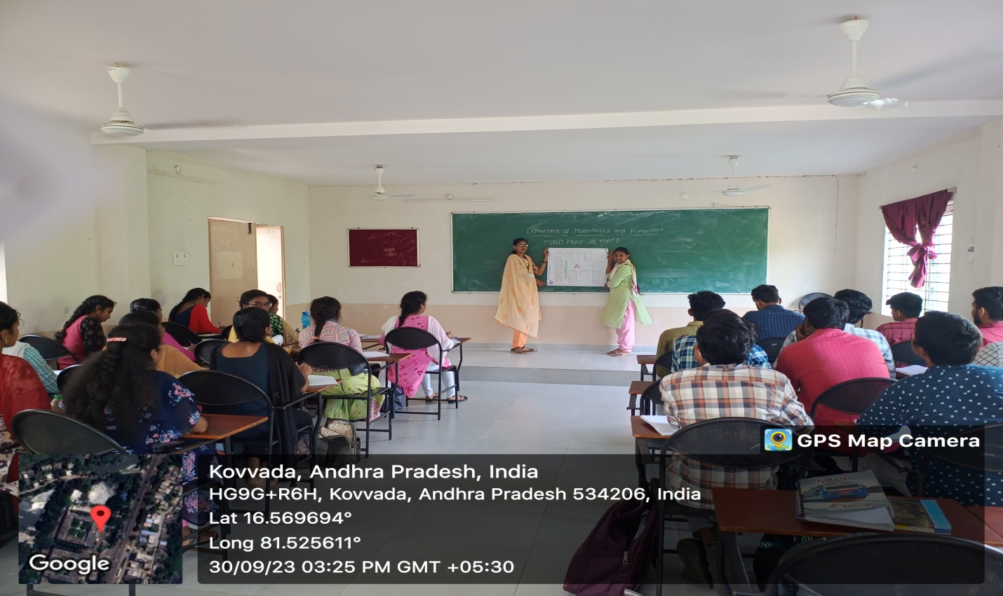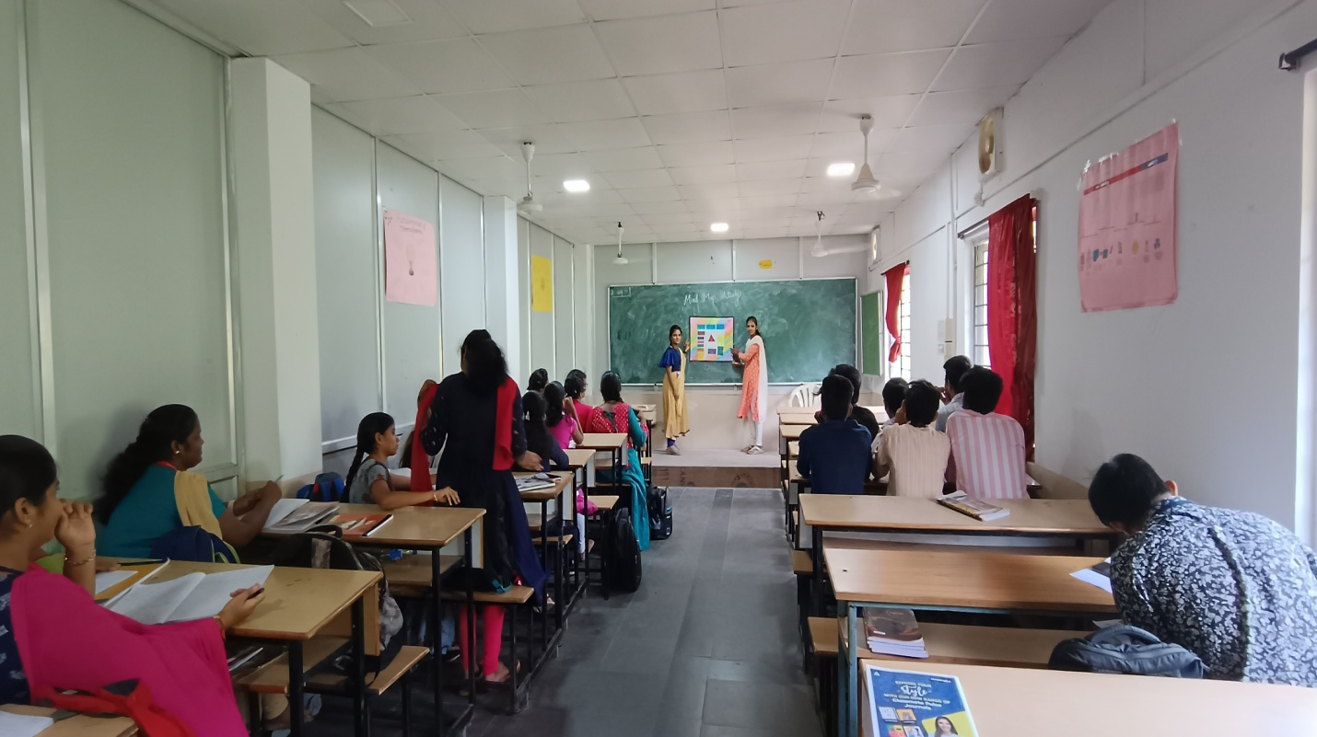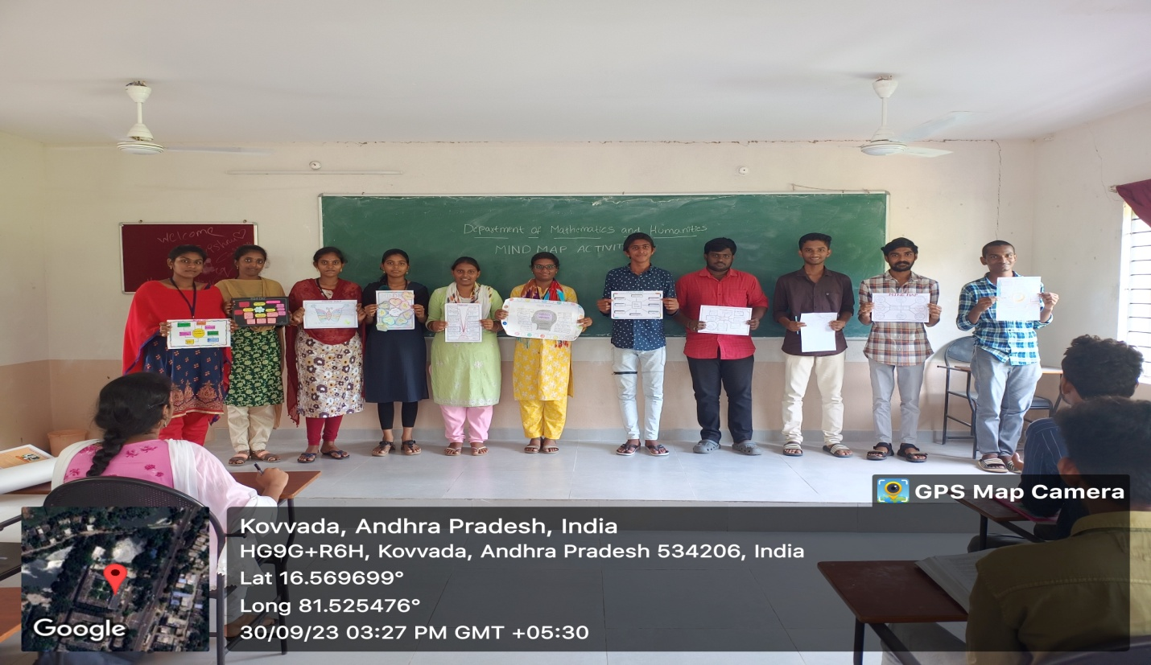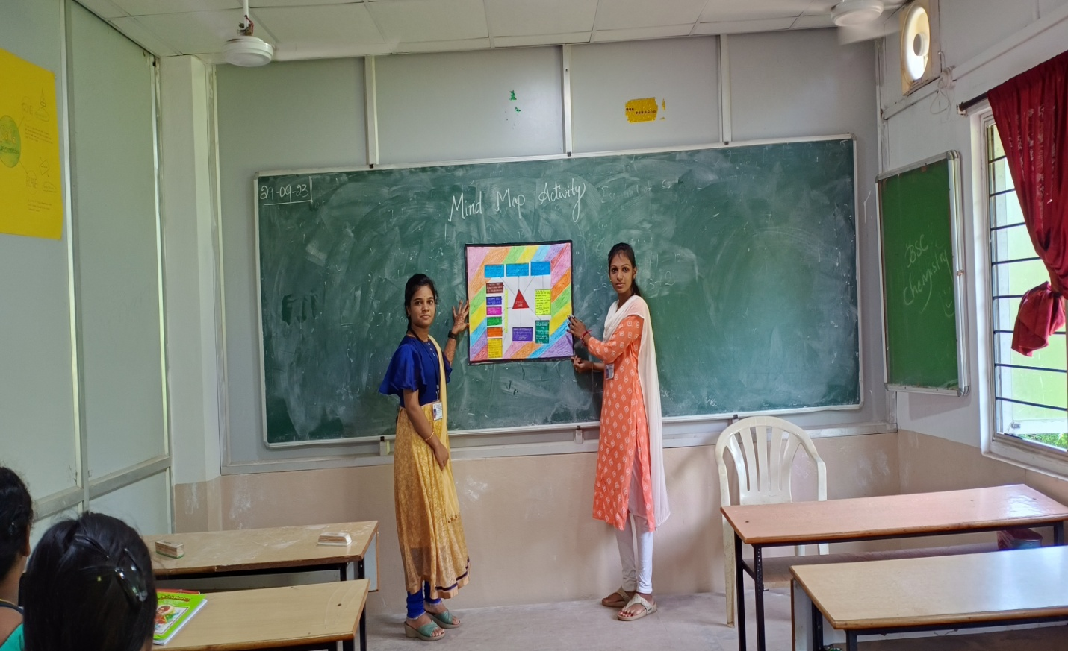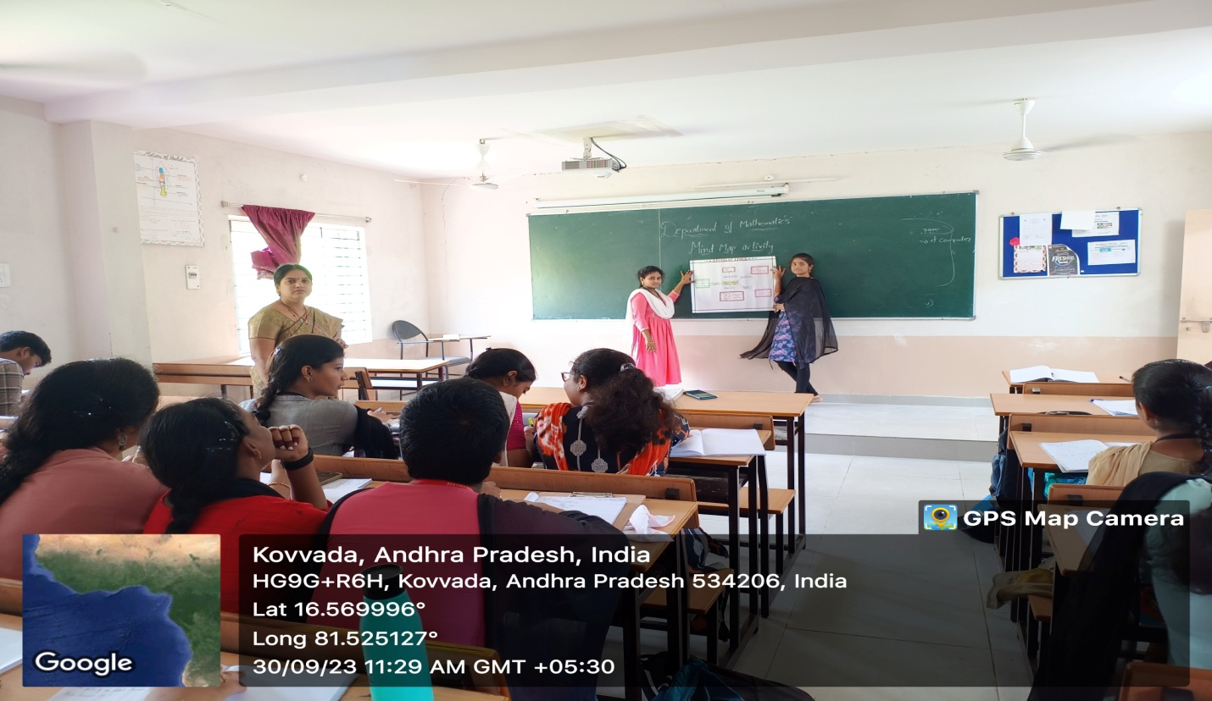
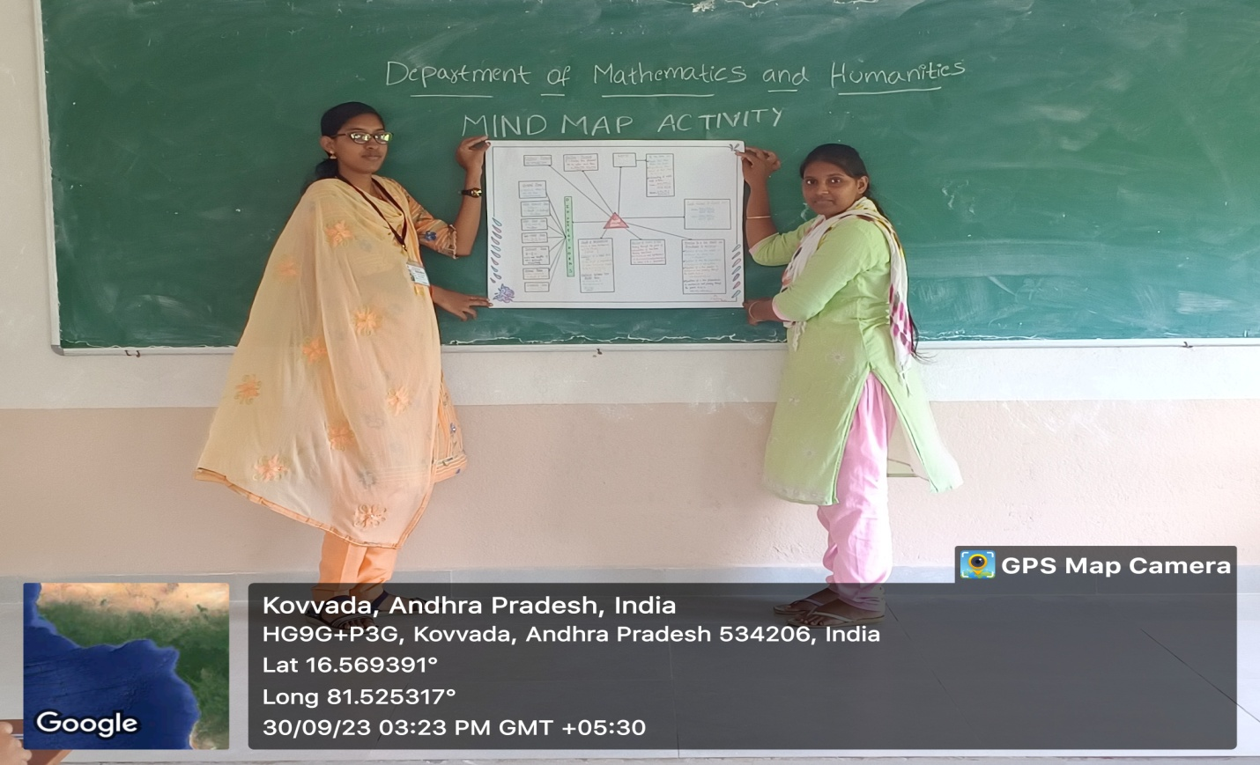

B V RAJU COLLEGE
VISHNUPUR :: BHIMAVRAM
DEPARTMENT OF MATHEMATICS & HUMANITIES
participants list
S.no | Name of the student | Group | Topic
1 | G. Poorna Shalini  M. Uma Devi  V. Mounika jahnavi | Data science | Straight lines
2 | M. Lalitha  K. Kavya | Data science | Straight lines
3 | B.Sushmitha  R. Yashitha | Data science | Complex numbers
4 | K. Rohith shekar  V. Jagadesh  B. Ram Teja | Data science | Complex numbers
5 | D. Chidvilas  T. Kishore  R. Mahesh Babu | Data science | Straight lines
6 | B. Sai prasanna  V. Devi prasanna  B. Jaya sree | Data science | Straight lines
7 | G.P.N.V.Bhavani  N. Divya sri  D. Jyothi sri | B.Sc., Chemistry | Complex numbers
8 | K. Vani poojitha  K. Hema sri  M. Sarayu | B.Sc., Chemistry | Straight lines
9 | T. Vani satya praveena  N. Sravani  V. Bhargavi | B.Sc., Chemistry | Straight lines
10 | G. Bruha vani  Ch.Keerthi | B.Sc.,C & P | Straight lines
11 | K. Mounika  T. Greeshma | B.Sc.,Physics | Complex numbers
12 | P.Satya  V. Lakshmi sirisha | B.Sc.,Physics | Complex numbers
13 | D. Ravi teja  K. Raju  V. Santhosh | B.Sc.,C & P | Straight lines
14 | T.Kumar eswar chandra | B.Sc., M & S | Straight lines
15 | K. Kevin Peterson | B.Sc., M & S | Straight lines
16 | G.Naresh | B.Sc., M & S | Complex numbers
17 | V. Prasanna | B.Sc., M & S | Straight lines
18 | M. Bhagravi | B.Sc., M & S | Straight lines
19 | K. Bhavani | B.Sc., M & S | Complex numbers
20 | G. Komali | B.Sc., M & S | Complex numbers
21 | P. Jyoshna | B.Sc., M & S | Straight lines
22 | M. Leela | B.Sc., M & S | Complex numbers
23 | M. Kinnera | B.Sc., M & S | Complex numbers
24 | M.N.S.S.Teja | B.Sc., M & S | Straight lines
25 | D.Manikanta | B.Sc., M & S | Straight lines
26 | I. Varshini | B.Sc., Cs-B | Matrices
27 | K. Madhu | B.Sc., Cs-B | Straight lines
28 | Y. Gheeshmi  Y. Usha  S.Alekya | B.Sc., Cs-C | Straight lines
29 | P.L.N. Pravallika  Sk. Beebi | B.Sc., Cs-C | Straight lines
30 | Ch. Vishitha | B.Sc., Cs-A | Matrices
31 | B.V.Rajyalakshmi | B.Sc., Cs-A | Integration
32 | G. Amrutha Varshi | B.Sc., Cs-A | Matrices
33 | Ch.Prasanthi | B.Sc., Cs-A | Matrices
34 | B.Keerthi | B.Sc., Cs-A | Straight Lines
35 | G.Manasa | B.Sc., Cs-A | Integration
36 | G.Sirisha | B.Sc., Cs-A | Integration
37 | S.Valli Padma | B.Sc., Cs-C | Integration
38 | T.H.S.N.Indumathi | B.Sc., Cs-C | Integration & Complex numbers
39 | Y.H. S.S.N.Lakshmi | B.Sc., Cs-A | Integration
40 | S.Jahnavi | B.Sc., Cs-C | Integration
41 | P.Sowmya | B.Sc., Cs-A | Trigonometric Functions
42 | K.V.Sujana | B.Sc., Cs-B | Complex numbers
43 | N.Nihariki  P.Lavanya  N.Santoshi | B.Sc., Cs-B | Statistics
44 | Y.Geeshmi | B.Sc., Cs-C | Trigonometric Functions
45 | K.Sharoni  M.Ramya  K.Tejaswi | B.Sc., Cs-B | Statistics

*************

